Atlantic Congress and Commissioning
June 18 – 20, 2010
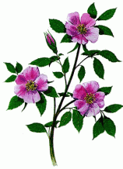
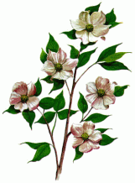
March Prayer Focus:
“SPRING = new life”

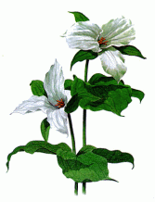
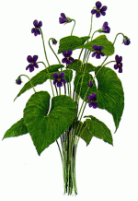
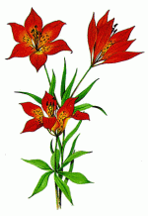
COMMENTS: March 20th marks the first day of spring. Spring: so full of life in its various forms. Birds singing, grass turning a lush green. Flowers blooming. Much like the flowers on this Prayer Focus. They represent the 10 provinces, 3 territories and Bermuda. Jesus said in John 10:10 that He came so that we might have life, and have it to the full. Just like the seeds/bulbs of these flowers push back the earth and burst into new life in springtime so our souls once dead in sin can also burst into new life in Christ Jesus. In other words ‘Springtime in our souls’!! II Corinthians 5:17 from The Message says, “Now we look inside, and what we see is that anyone united with the Messiah gets a fresh start, is created new. The old life is gone; a new life burgeons! Look at it! All this comes from the God who settled the relationship between us and him…”

SCRIPTURE READING: John 10:10 John 14: 6 Colossians 3: 13 - 15
John 20: 31 Ephesians 2: 1 - 10

PRAY: - For souls, more souls
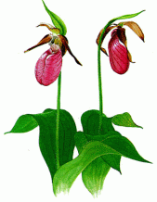
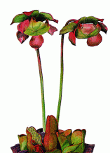
- For new life in Christ for our family members
- For new life in Christ for our friends
- For new life in Christ for our neighbours
- For new life in Christ for those who live in our communities
- Souls, more souls
- With thanksgiving for the precious gift of our salvation – new life!

SUGGESTED MUSIC:
Choruses - My Life Is In You Lord
- White As Snow
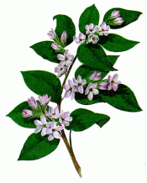
- Spirit Song (O Let The Love Of God Enfold You)
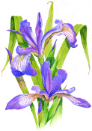
- I Come To The Cross
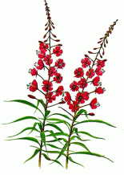
- Lord Lay Some Soul Upon My Heart

S.A.Songbook - # 393 – We Have heard The Joyful Sound
- # 691 – Rescue The Perishing

Solo: Softly And Tenderly Jesus Is Calling
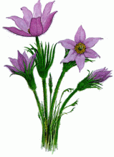
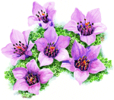
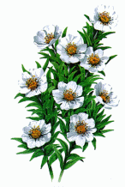
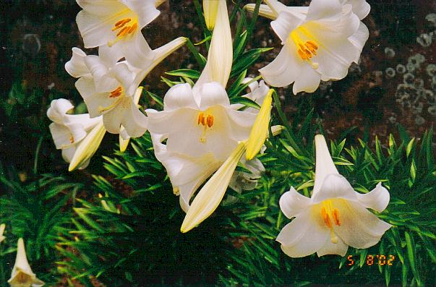
CHALLENGE: New life in Christ. It’s Our Destiny…

