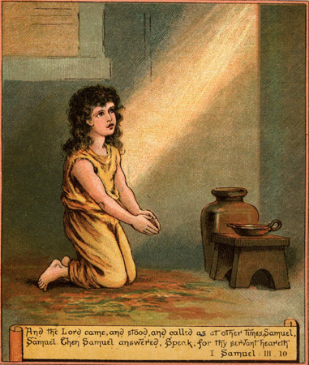
Atlantic Congress and Commissioning
June 18 – 20, 2010

June Prayer Focus

“A COOL call”
COMMENTS: A mom and her teenage son are traveling home one day. The conversation covers several topics including what the son wanted to do once he finished high school. Various options are mentioned. Mom asks if he’s thought about being a Salvation Army officer? The son asks, “Don’t you have to be called by God for that?” Mom says “Yes.” The son asks what her call was like. Mom explains: “I heard my name being called: much like Samuel in the Bible when he heard someone calling his name. That’s what it was like. I heard very clearly God calling me by name. I knew then that God was calling me to be a Salvation Army Officer.” Mom wasn’t sure what the son would say and wasn’t quite prepared for what came next. Her son said, “Cool!” After a brief noment mom agrees, “You’re absolutely right son, it is cool!” ‘The Call’ is cool (awesome, amazing)! AND sacred (dedicated, set apart, devoted). It can be both.

SCRIPTURE READING: I Samuel 3: 1 – 10 Jonah 1:1 – 2: 9
Matthew 4: 18 – 22 Luke 9: 57 - 62

PRAY FOR: - new Lieutenants* (Prayer Warriors Session) who will be commissioned, their
familes, first appointments
- cadets* (Ambassadors of Holiness Session), their families, summer assignments
- farewelling officers, their families, new appointments
- retired officers
- candidate recruitment

SUGGESTED MUSIC:
Choruses - I Have Decided
- I’ll Follow Thee Of Life The Giver
- In Christ Alone
- All I Once Held Dear
- The Greatest Thing In All My Life

Songbook # 463 – For Thy Mission Make Me Holy
# 472 – A Charge To Keep I Have

Solo: I Would Be Thy Holy Temple
CHALLENGE: When God calls us, we must answer! It’s Our Destiny…
* Pictures attached

