SUGGESTED MUSIC – April Prayer Focus
THE BATTLE BELONGS TO THE LORD
In Heavenly armor we’ll enter the land,
The battle belongs to the Lord.
No weapon that’s fashioned against us will Stand,
The battle belongs to the Lord.

We sing glory, honor,
Power and strength to the Lord.
We sing glory, honor,
Power and strength to the Lord.

When the power of darkness comes in like
A flood,
The battle belongs to the Lord.
He’s raised up a standard,
The pow’r of His blood,
The battle belongs to the Lord

When your enemy presses in hard, do not fear,
The battle belongs to the Lord.
Take courage , my friend, your redemption is Near,
The battle belongs to the Lord.
(©1984 And This Arr. © 1997 Fairhill Music ASCAP. )

JESUS, YOUR NAME
Jesus, Your name is power,
Jesus Your name is might.
Jesus, Your name will break
Ev’ry stronghold;
Jesus, Your name is life.

Jesus Your name is healing.
Jesus Your name gives sight.
Jesus, Your name will free
Ev’ry captive;
Jesus, Your name is life.

Jesus, Your name is holy,
Jesus, Your name brings light.
Jesus, Your name above
Ev’ry other,
Jesus, Your name is life.
(©1990 And This Arr. © 1997 Marnatha! Music And Word Music)

WE’VE GOT THE POWER
We’ve got the power in the name of Jesus; We’ve got the power in the name of the Lord. Though Satan rages, we will not be defeated, We’ve got the power in the name of the Lord.

IN THE NAME OF JESUS
In the name of Jesus,
In the name of Jesus
We shall have the victory.
In the name of Jesus,
In the name of Jesus,
Demons will have to flee.
When we stand in the name of Jesus,
Tell me who can stand before
In the name of Jesus, Jesus
We shall have the victory.

*****************************

THE CREST: It’s meaning

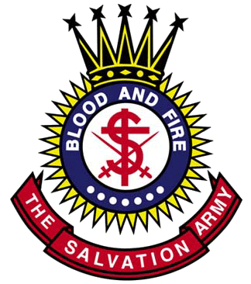

(a) The round figure 'the sun' represents the light and fire of the Holy Spirit
(b) The cross in the centre represents the cross of our Lord Jesus Christ
(c) The letter ‘S’ around the cross stands for Salvation
(d) The swords represent the warfare of salvation
(e) The dots represent the truths of the gospel
(f) The crown represents the crown of glory, which God will give to all his soldiers who are faithful to the end
g) The motto ‘blood and fire’ represents the blood of Jesus shed for our sins and the sanctifying fire of the Holy Spirit

