Atlantic Congress and Commissioning
June 18 – 20, 2010
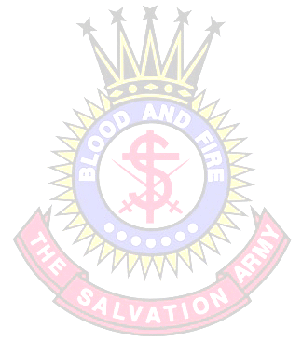
April Prayer Focus

“WHAT EVER NEXT?”

COMMENTS: In 1878 Captain William Ebdon submitted a design for a Salvation Army crest. It became so popular after the 1878 congress, appearing on headgear. It was registered as a Trade Mark in 1884 on a number of items including knives, soap and buttons. What’s interesting is that in response, a journalist of that day wrote, “What ever next?” It is unclear as to what was meant by the question. Was it disapproval of the crest and its meaning? Disapproval of the crest on household items? Who knows? Well, as another Congress draws near can that same question be asked again? Not in a negative way but in an honest and thought-provoking way: What IS next for The Salvation Army? Will we be ready and willing to address the ever increasing and complex challenges of ministry and needs of society? Regardless of what ever is next we must consistently, and with integrity, meet these challenges using the gospel message in the crest as our motivation: that Jesus, through His life, death and resurrection, has conquered sin and death for us; that through the indwelling Holy Spirit we may all become Christ-like; that we remain faithful to God in this ongoing spiritual warfare and thereby inherit eternal life. We must keep this message in the crest ever before us should we be asked to give an answer to that age old question: “What ever next?”

SCRIPTURE READING: Ephesians 6: 10 – 18 II Timothy 2: 1 - 13

PRAY FOR: - The Salvation Army as a church and an organization
- The Salvation Army to always be a holiness movement
- General Shaw Clifton and Commissioner Helen Clifton
- The Salvation Army Territorial Executive Leadership
- The 2010 Congress participants (from guest speakers to musical groups,
from daycare workers to congregations, from youth to seniors, from
parking attendants to audio/visual personnel, from ushers to seekers)

SUGGESTED MUSIC:
Choruses - The Battle Belongs To The Lord
- Jesus Your Name
- We’ve Got The Power
- In The Name Of Jesus

Songbook - # 808 – Let Us Sing Of His Love Once Again
- # 811 – Marching On In The Light Of God
CHALLENGE: To be ready for ‘what ever next’! It’s Our Destiny…

