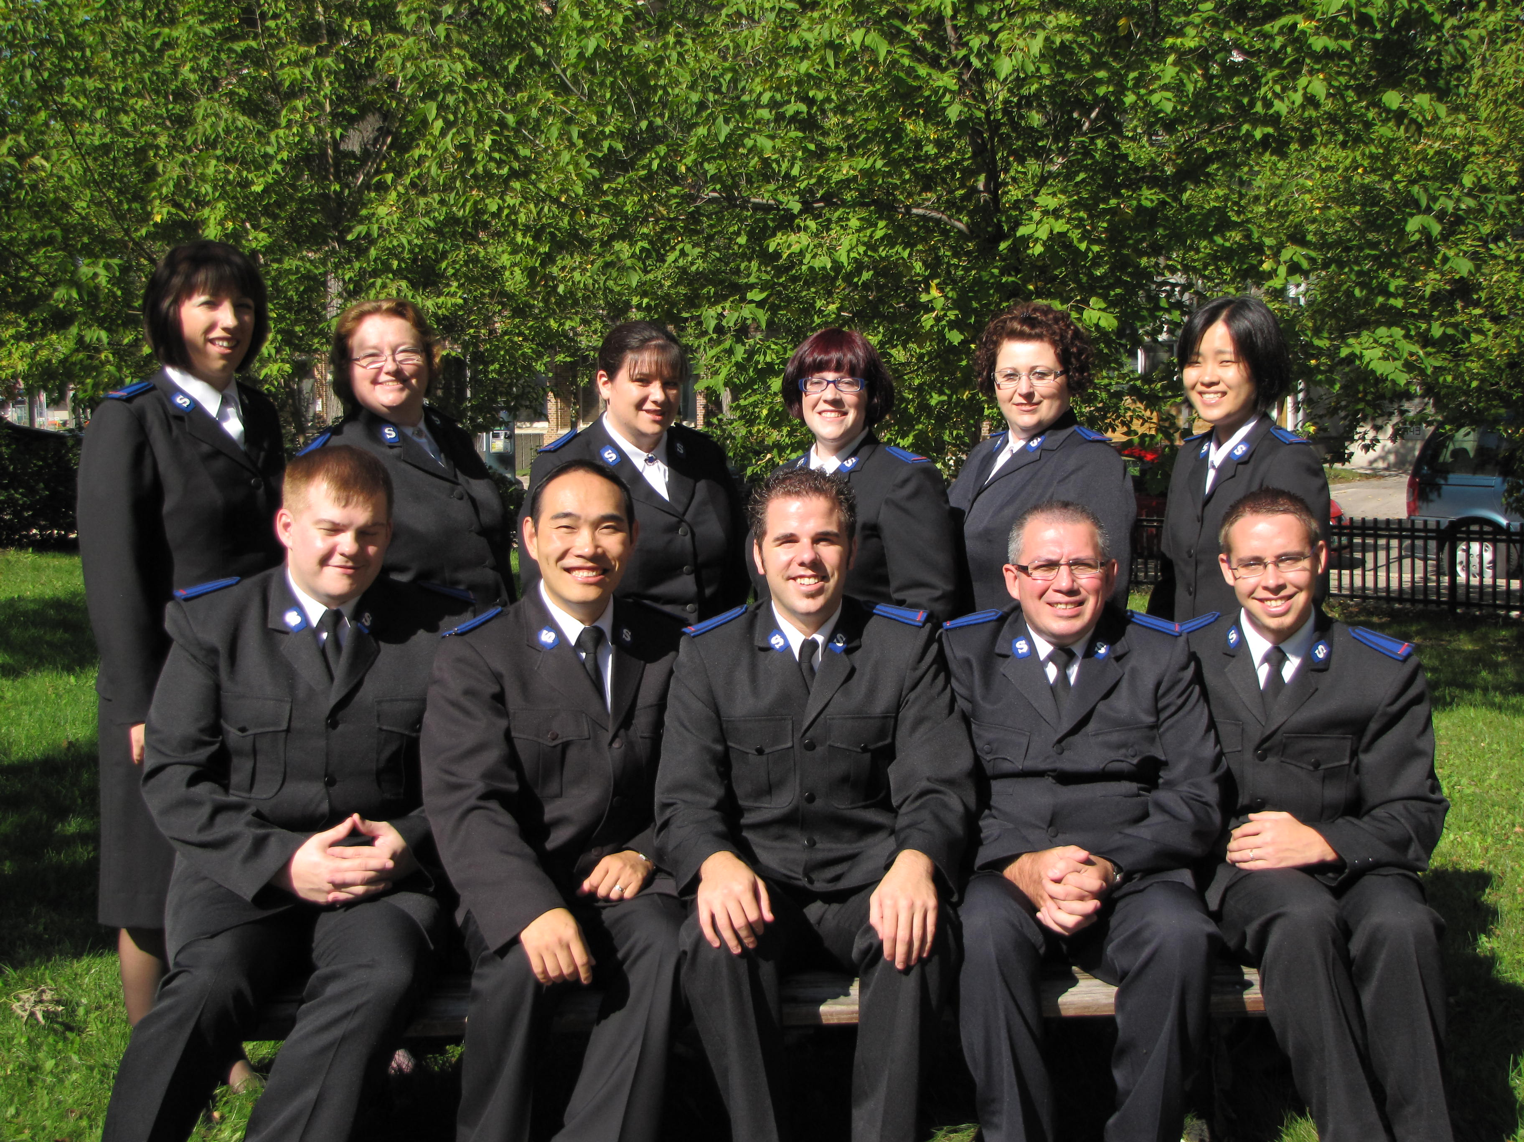
Ambassadors of Holiness 2009-2011

Front Row (L-R): Cadets: Darren Woods, Peter Kim, Joshua Downer, Chris Street, Jason Waters

Back Row (L-R): Cadets: Joyce Wilson, Sharyl Marriott-Lowry, Jaclyn Wynne, Kyla McKenzie, Tonia Street, Grace Kim

