the Salvation Army would like to thank

**for their support of the 2018 Christmas Kettle Campaign.**

**The Salvation Army is passionately committed to eradicating poverty and**

**caring for people who are struggling. The funds raised at Christmas support**

**our work year round including programs for the homeless, food banks**

**for those trying to make ends meet and support services for families.**

Awarded this ___ day of __________, 2018

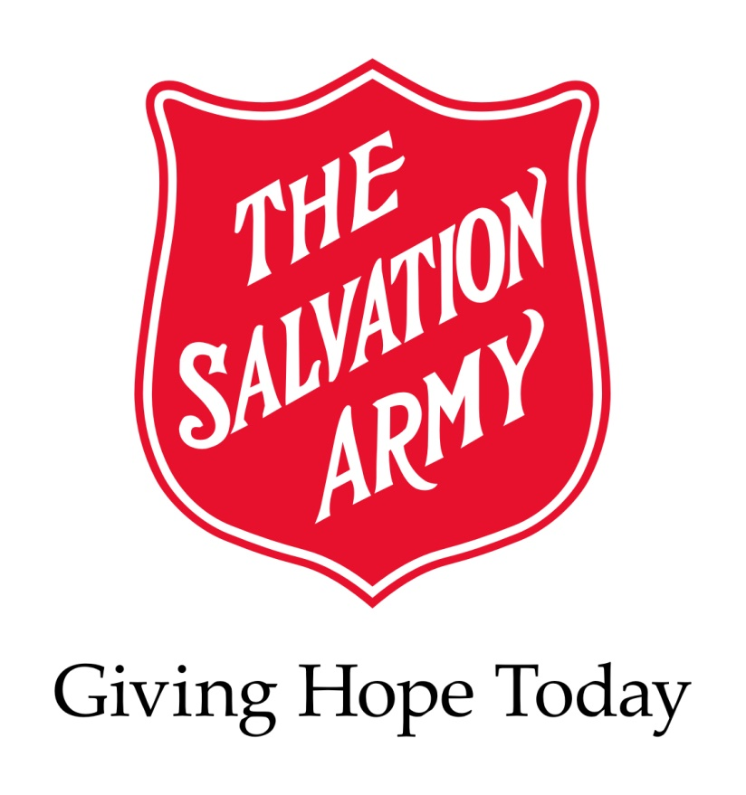

# certificate of thanks



Presenter Name and Title