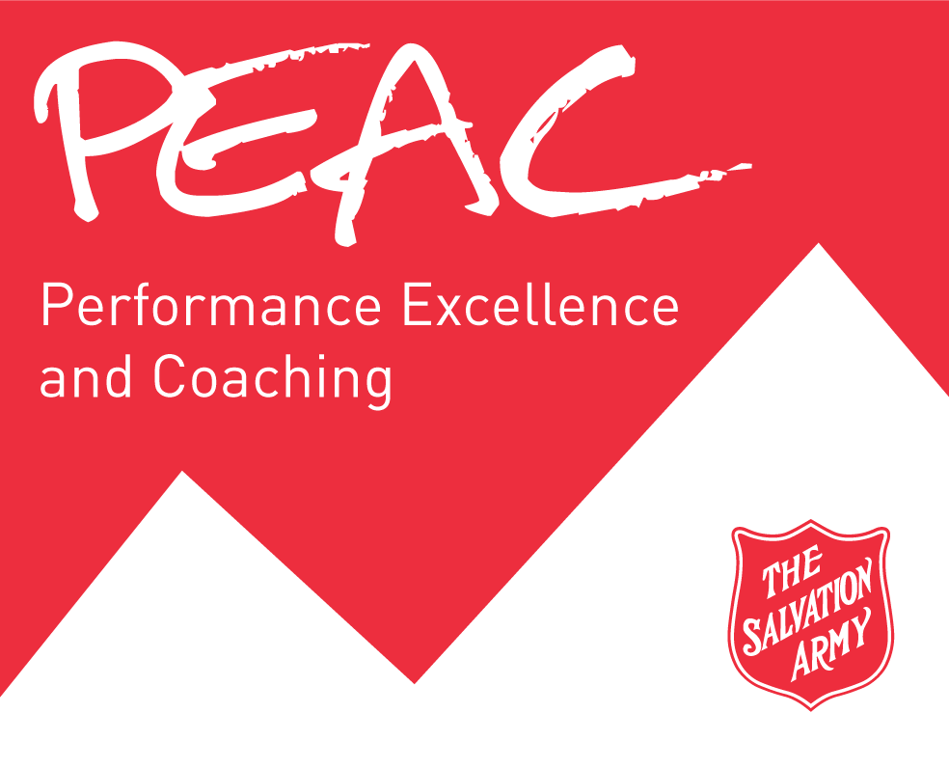
Employee Development and Annual Review Form
The Salvation Army Canada & Bermuda Territory

Employee: |  | Year:
Supervisor:
Process
- At the beginning of the review period, the supervisor and employee jointly identify 3-5 priority goals for the employee within the context of The Salvation Army mission and territorial strategies and priorities, and the key accountabilities of the role.
- Supervisor meets with the employee to review the goals and discuss what successful achievement of the goal will look like.
- Supervisor uses the Performance Coaching form to provide employees with feedback throughout the year and document their progress.
- Year-end assessment is to be completed separately by the employee and supervisor prior to the meeting where the assessment will be finalized.
 | My Goals | What would it look like/milestones? | Year-end  Comments
1.
2.
3.
4.
5.
Note: Goal should be a concise, specific, measurable, time- Note: State how the goal will be actioned, measured, Note: Assess the achievement/non-achievement of the
bound statement that is connected to position expectations the timeline, resources needed. desired outcomes, including assessment of
or desired development. competencies and areas for development. State any
next-step expectations that may be necessary.

Interpersonal Skills | Comments
Demonstrated ability to work successfully with other people. | (What is working well? Identify any areas for development)
Organizational Commitment | Comments
Demonstrated ability to operate within the Salvation Army Values. | (Review The Salvation Army Mission and Values Statements. Discuss any apparent incongruence.)
Overall Assessment | Comments
Demonstrated Competencies:
Areas for Development:
Employee Comments (include career/ministry aspirations):
Commencement of Year:

End of Year:

Supervisor Comments:
Commencement of Year:

End of Year:

We have jointly developed this PEAC and agree to actively monitor and adjust this plan as required based on feedback and discussion throughout the year.
Commencement of Year:
Employee Signature: |  |  | Supervisor Signature:
Date: |  |  | Date:

End of Year:
Employee Signature: |  |  | Supervisor Signature:
Date: |  |  | Date:

DC/DH/AC Signature
(as required):
Date:

12-17-2014

