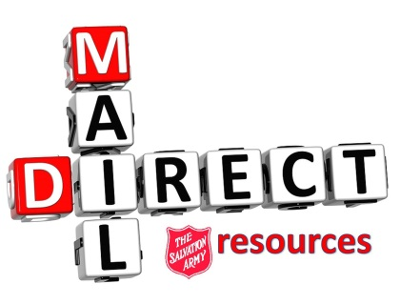

The Value/Importance of Red Shield Fundraising:
The OCE Division relies on Red Shield (RS) revenue to support the many social programs being run. The Division receives 64% of all RS funds collected, which means that the Public Relations and Development office must do all it can to raise as much RS revenue as possible.
One of the largest sources of RS revenue comes from Direct Mail.
While Direct Mail (DM) revenue is on the decline, it continues to prove necessary and successful with many of our older donors. DM is also a great tool to push donors to give via 1-800-SAL-ARMY and online at SalvationArmy.ca.
While RS revenue does not find its way directly back into the community in which it is collected, all communities have access to RS funds, and RS supported programs.
Telling a donor to “just give locally” and that by giving to the DM campaign the money just goes to ‘Toronto’ is not only a fallacy, but an injustice to others in need.
Red Shield revenue affects each community. Children from all over the division have access to the camp. All units have access to Railside Food Distribution. Inmates being visited by Correctional and Justice Services personnel come from all over. And those who take advantage of TSA’s Homeless Support Services have often come from other places.
To date, during the 2014-2015 FY, DM has directly raised over $5.3 million.

