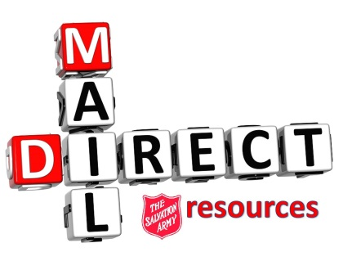

How to remove a name from the mailings:
The process is simple – email the donor’s name and full address to donor_questions@can.salvationarmy.org, with an explanation as to why the name is to be removed.
Things to keep in mind:
- Names are not removed from the donorbase, they are simply coded not to receive mail. However, with each name coded as such, that represents lost Red Shield revenue, resulting in less money available to be given out by the division.
It is recommended that if a local resident calls to complain about receiving too much mail, ask them if we can send them two newsletters only (Spring and Fall). This will keep the brand in the forefront, provide information about programs, and will help maintain an ongoing relationship with the donor.
In this case, the email to donor_questions@can can state to code the donor NEWSLETTERS ONLY.
- Coding donors “No Mail” excludes them from the world services mailing, which is a detriment to our commitment overseas.

- “PROSPECT” mailings: donors who receive prospect mail are not on the database. They are given a temporary donor number, and only added to the donorbase once a gift is given. Because lists are rented from various sources, we try to ensure that all duplicates are removed. Unfortunately, some donors/households do receive prospect mailings.

- If a donor calls about getting duplicate mail, please email donor_questions@can. It is best if you can get hold of the mailings so that we can research them, in order to resolve the error.

Any questions or requests for clarification can be directed to jeff_robertson@can.salvationarmy.org

